sibusiso

St10125398@rcconnect.edu.za

Computer networking has taken the world by storm and it continues to demonstrate its importance, in this document we will look at how we configure servers and how user privileges are grunted to users that are being created.

Network  
ADMINISTRATION

Network configuration and installations

# Contents

### Purpose of the document: ......................................................................................................................1

### Overview of the solution: .......................................................................................................................1

### ASSUMPTIONS MADE: ............................................................................................................................1

### How the solution is meeting the business goals: .....................................................................................1

### Plan as well as the design of the server environment: ............................................................................1

### Plan and the design of local storage: ......................................................................................................1

### Plan as well as the design of file and share access: ................................................................................1

### Plan as well as the design of print and document services: ....................................................................1

### Plan as well as the design of remote management for servers: .............................................................1

### Recommendations: ................................................................................................................................1

# Purpose of document.

We are required to plan the installation and configuration of a Home Affairs department along with its other branches. This document servers as a blueprint of some sort to carefully guide one through troubleshooting if they may encounter problems or something turns out badly, the document will

serve as a convenient reference to direct the troubleshooting exertion, it will save a lot of resources as well as capital be directed to this project.

## Overview of the solution.

* We firstly going to install Windows Server Domain there after create each of the three sites

A Windows domain is essentially a form of a computer network in which all user accounts, computers, printers and other security principles are registered with the central database located on one or more clusters of central computers known as domain controller of controlled computers. In business this is what is frequently used to manage a business network and more so we going to use this for our Head office in PTA. At least one server we are going to have running which will be our standard

domain controller and will be in charge of the other devices. That is why it will be installed in

Pretoria, the Head Office of Home Affairs. This lets the network administrators such as

myself to control the computers on the domain through users, settings, and more.

2. An adequate Domain Controller strategy is planned and implemented

A domain name server -a directory-based network server responsible for maintaining rhea directory of network objects and managing user authentication and authorization. (Aan Dennis, 2013, p. 119)

As We have established, we have a forest with 3 secondary domains. At the moment we have 2 physical

domain controllers which are the main domain and 6 virtual domain controllers for our

secondary domains. The strategy I have implemented is to back up the Primary

Domain Control for the main domain and then the Primary Domain Controller for each of

the secondary domains. The Domain Controllers that are holding the Primary

## Domain Controllers roles are also on the other hand holding the other

roles as well. The others won’t be backed up. The backup involves using windows backup

for the physical DC and a VSS backup utility for the virtual DC's. I then take system state

backups for each PDC three times a day as well. As long as I have the PDC for each

domain and the root I should be ok. The theory being the backups are for granular

recovery purposes and or DR scenarios.

3. Domain functional levels are configured

They represent advanced features that are available with the newest software that can be

used in the domain. Usually when you administer large AD environment you will notice

that you have different Windows OS versions on your DCs. If you have DCs that are 2008

R2, 2012 and you install 2016 you will not be able to use latest advanced features that

comes with 2016 until you upgrade all you DCs to 2016 and raise functional level. AD

features are not backward-compatible with AD domain controllers on earlier versions of

Windows Server so if you are running 2008 R2 and you install 2016 you will be limited to

those features that comes with 2008 R2. Functional levels can be used to decide which

DCs are allowed to run in our environment. For example, if we raise functional level to

2016 we will not be able to install 2012 R2 DC in our domain. You cannot set the domain

functional level to a value that is lower than the forest functional level, but you can set it

## to a value that is equal to or higher than the forest functional level. This is all standard procedure for ensuring our DC’s work very well.

**Strategy implementations**

* Here we can simply create a list of all the sites customers rely on to get information and what they are and how we can use it to our advantage. struggling to create a list).
* We gather information of all sites that might be of benefit to our strategy implementation.
* We need to find or know what the average citizen is thinking what are they reading and what source provide them with information and what are they reading?
* We need to figure out which sites would provide the best referrals to us and in turn we would get referral traffic from them.
* Here we can simply create a list of all the sites customers rely on to get information and what they are and how we can use it to our advantage. struggling to create a list).
* Active Directory objects are created for the entire domain. This includes secured user, group and

computer accounts are created and administered

* local storage, file and share access is configured
* print and document services are configured
* remote management strategy is planned and implemented

# ASSUMPTIONS MADE:

All required components have been purchased namely the hardware components and network configurations are being troubleshooted and configured at present.

We have to look at types of servers that can be used as we have multiple servers out the and here we can have a look at quite a few of them available out the/

* **Mail Server** - Almost as ubiquitous and crucial as Web servers, mail servers

move and store mail over corporate networks (via LANs and WANs) and across

the Internet.

* **Web Server** - At its core, a Web server serves static content to a Web browser

by loading a file from a disk and serving it across the network to a user's Web

browser. The browser and server talking to each other using HTTP mediate this

entire exchange.

* **Telnet Server** - A Telnet server enables users to log on to a host computer and

perform tasks as if they're working on the remote computer itself.

**Operating systems** –Is a software that communicate with the hardware and

enables other programs to run. It is involved of system software, or the

fundamental file your pc needs to boot up and function.

We are going to need a few applications which are.

* IT project
* Microsoft Visio
* Expression Web 4
* Microsoft Office
* Hub- A hub is the central point of connection for cables segments in a physical star topology. Technically, a hub is multiport repeater for use with twisted pair cable. Some hubs can also provide different services, depending on the sophistication.
* Switch – a switch is a connection device similar to a hub but more sophisticated including functionality that allows it to control and manage the data transmissions.

How the solution is meeting the business goals:

Customer satisfaction offering better services to our clients

• home affairs will have a fast-running system that will prevent backlogs as the be one server available.

* An easy way of trouble shooting problems of failure as the point of fail will be easily identified.

• Home issues will presently have the option to have an obvious activity as the

new system will be actualized and there will be compelling and productive

security.

• IT uphold office at the division of Home Affairs will meet its long expression

objectives through the representative s abilities efficiency increments.

* Works at the office can be prepared and can have more information about the system executions.

• Security and system frameworks at Home Affairs will be improved with the

goal that they can be effective enough to expand efficiency.

Models: Access to the system security of Home Affairs will be denied as

individuals normally fry to get to others data

# Plan as well as the design of the server environment:

3 servers will be available One at the head office and one at each of the two

Branches (ALL servers are active directory domain controlled)

The centralized server is located in the Pretoria Office. Your biggest project is to

configure a centralized integrated network for Home Affairs only focusing on the following departments and areas for each branch office.

* ID and Passport Department;
* Birth, Marriage and Other Certificates Departments;
* Foreign Affairs Department;
* IT Support Office;
* Administration Support Office.

To accomplish the above, you are first required to pilot the domain configuration solution on two branch offices in addition to the head office.

different devices on a network. It is a primary feature of Windows Server, an

operating system that runs both local and Internet-based servers. Active

Directory allows network administrators to create and manage domains, users,

and objects within a network “

DHCP-is a network management tool that works alongside two other protocols,

namely the Transmission Control Protocol (TCP) and the Internet Protocol (IP),

both of which are required in order to connect devices to each other and to a

network. The main purpose of DHCP is to automate the management and

configuration IP addresses across a network, so that IPs don't need to be

manually assigned by an admin each time a device connects

DNS-is a PC server that contains a database of public IP addresses and them

related hostnames, and in most cases serves to resolve, or make an

interpretation of, those names to IP addresses as mentioned. DNS servers run

unique software and communicate with each other using special protocols.

Print-is a device that allows you to share a printer with multiple computers. It

may be a standalone adapter or may be integrated within a printer or a router.

# Plan and the design of local storage:

Local storages are an innovation in Windows and Windows Server that can help

shield your information from drive failures. It is similar to RAID implemented in a storage pool and afterward use capacity from that pool to create Storage

Spaces. These commonly store additional duplicates of your information so if one of your drives fails, simply add more drives to the storage pool.

To create storage spaces, you need at least two internal or external drives. You

can use a variety of types of drives with Storage Spaces, including USB, SATA,

and SAS drives. The following are steps on how to create storage spaces:

* Add or connect the drives that you want to group together with Storage

Spaces.

* Go to the taskbar, type Storage Spaces in the search box, and

select Storage Spaces from the list of search results.

* Select Create a new pool and storage space.
* Select the drives you want to add to the new storage space, and then

select Create pool.

* Give the drive a name and letter, and then choose a layout. Two-way

mirror, Three-way mirror, and Parity can help protect the files in the

storage space from drive failure.

* Enter the maximum size the storage space can reach, and then

select Create storage space.

# Plan as well as the design of file and share access:

For the utilization of File at first, we should start by making a web application and

host is on our Main specialist that is at our Head office at PTA. Inside this web

Application, the customers can move and download records of different sorts

like chronicles, sounds, books Two stages for the execution of web application

* Design the data set This incorporates tables of data about clients and

transferred documents.

* Design the site pages This is spoken to by both the worker side and the

customer side.

After the planning of the application web that will permit us to make the

document we utilize the principal worker to test. Since the cycle utilized is

replication we will after go to our optional workers that are based at KZN and

GAU and do a few setups.

After we planned the File for all the Branches, we going to make an authorization

structure for records and organizers for our clients to acquire consents for an

article dependent on gatherings of which he is a part. You give this security

utilizing the document frameworks worked in to our Main worker. Our worker

remembers another instrument to help you for deciding viable consents when a

client has NTFS authorizations from numerous sources.

Plan as well as the design of print and document services:

* Our Managed Print and Document Solutions provide a holistic ecosystem:

merging the physical with the digital to provide your business with cost

savings,

* improved visibility and control, automated processes for increased

productivity and enhanced information security. Through our subsidiary,

* Smart Office Connexon, we are able to assist organizations of any size

with solutions that include a host of technologies and services, available

on a variety of financial structures, all supported nationwide by our

industry leading service operation.

* The Managed Print Solutions (MPS) definition is broad, but the end result

is simple: gaining visibility and control of your printing, which helps you save money and boost productivity. (Aan Dennis, 2013, p. 250)

* Print policies control who can print, how they can print and how devices

are configured. We offer an all-round service to implement and

proactively manage print policies. Proactive monitoring and reporting

portals that integrate with organizations own systems enables us to cater

for specific requirements.

* Print job – a document that has the prepared and is ready to print and this will prove very beneficial for all our branches. (Aan Dennis, 2013)
* Print queue- a temporary storage location for print jobs waiting to print also known as print spooler. (Aan Dennis, 2013, p. 250)

Plan as well as the design of remote management for servers:

* Remote Server Administration Tools includes Windows PowerShell cmdlet

modules that can be used to manage roles and features that are running

on Remote servers. Although Windows PowerShell remote management

* RDS offers deployment flexibility, cost efficiency, and extensibility—all

delivered through a variety of deployment options, including Windows

Server 2016 for on-premises deployments, Microsoft Azure for cloud

deployments, and a robust array of partner solutions.

* The Remote Access server role is a logical grouping of these related

network access technologies: Remote Access Service (RAS), Routing, and

Web Application Proxy.

* Remote Desktop Services (RDS) is the platform of choice for building

virtualization solutions for every end customer need, including delivering

Individual virtualized applications, providing secure mobile and remote

desktop access, and providing end users the ability to run their

applications and desktops from the cloud.

# Recommendations:

Virtualization – s a software simulated computer. And the whole idea behind it is that to use software to simulate the existence of hardware (Aan Dennis, 2013)Virtualization refers to the use of creating or managing a virtual

version of a resource, such as a computer or server using software. So, Virtualization is a great way to put all of this unused processing power to use and the are other good benefits like:

* Hardware cost -you can save a lot of money by decreasing hardware costs and have everything is a host environment rather in the traditional ways of doing things. (Aan Dennis, 2013, p. 291)
* Energy costs – and having running the virtual organization have seen an improved amount fof their electricity usage as it has decreased significantly by 80% since the implementation of sever computers. (Aan Dennis, 2013, p. 291)
* Recoverability- and this is the most important one with virtualization companies can quickly recover from failures. (Aan Dennis, 2013, p. 291)
* Disaster recovery- in case of a huge disaster maybe a server room catches fire everything can be backed in a disk and no one has to worry about getting new hardware in and trying to get all the damaged goods from the. (Aan Dennis, 2013, p. 291)

References

(Aan Dennis, 2013, p. 119)

(Aan Dennis, 2013, p. 119)

(Aan Dennis, 2013)

(Aan Dennis, 2013, p. 250)

(Aan Dennis, 2013, p. 250)

(Aan Dennis, 2013)

(Aan Dennis, 2013, p. 291)

(Aan Dennis, 2013, p. 291)

(Aan Dennis, 2013, p. 291)

(Aan Dennis, 2013, p. 291)

Installation Active Directory

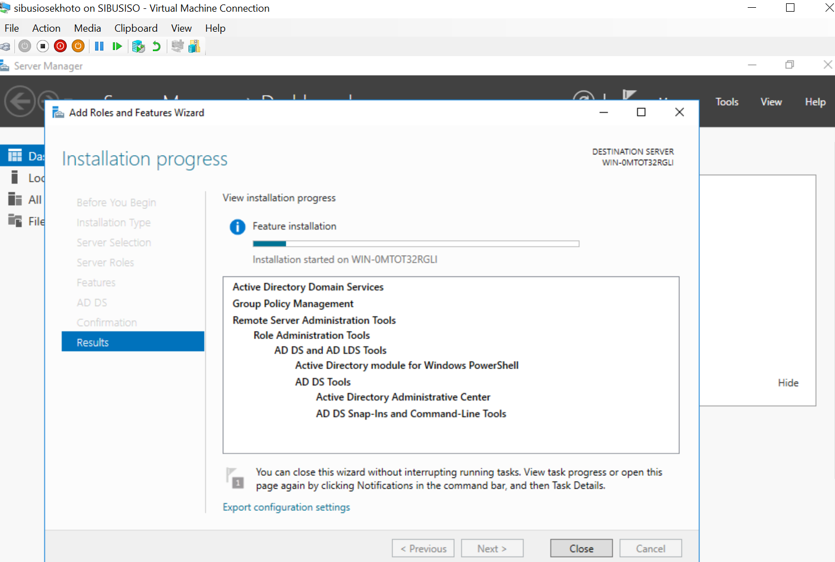

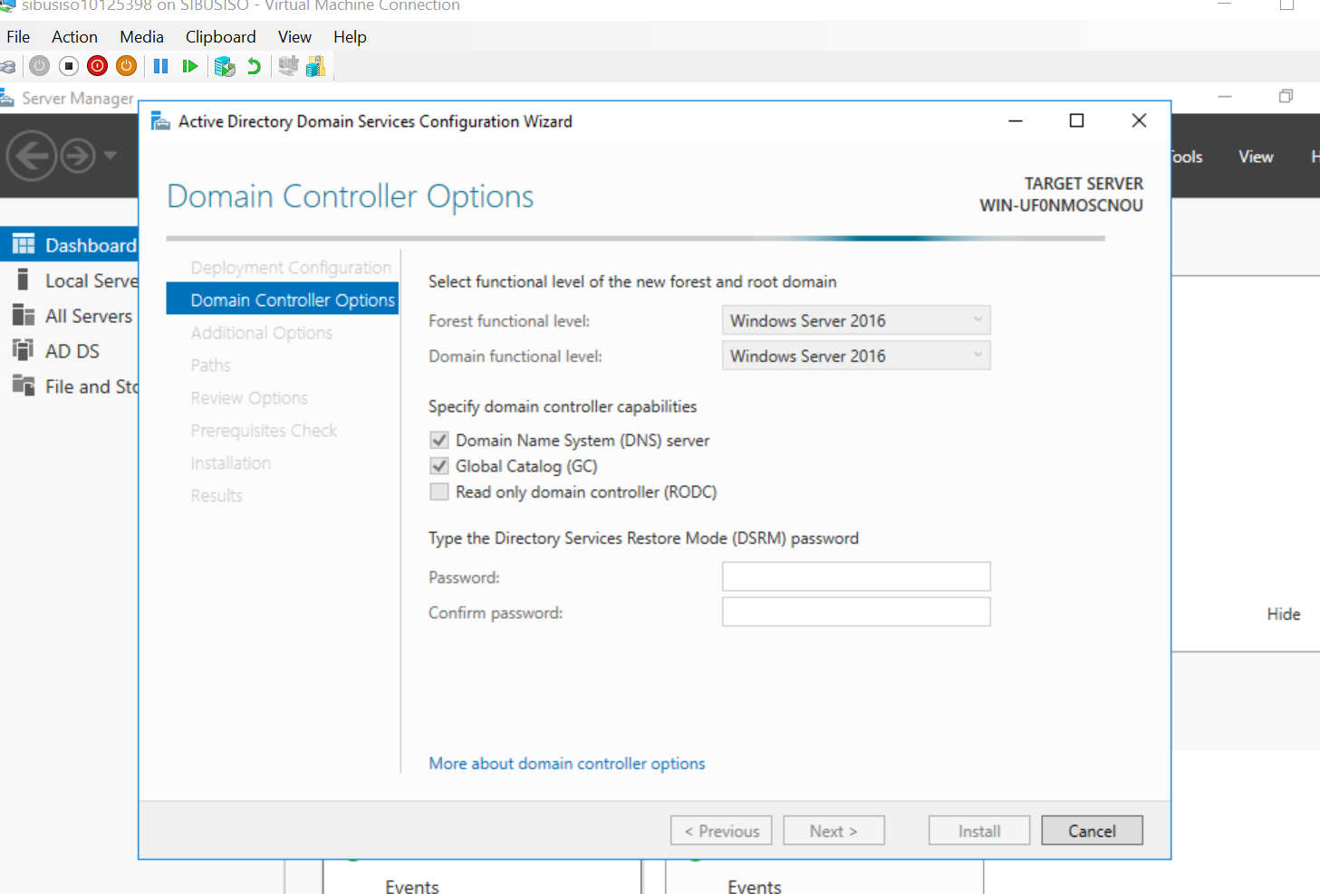

Activity 2

The network consists of: • Server machine showing the entire structure of the

network (head office and branches)

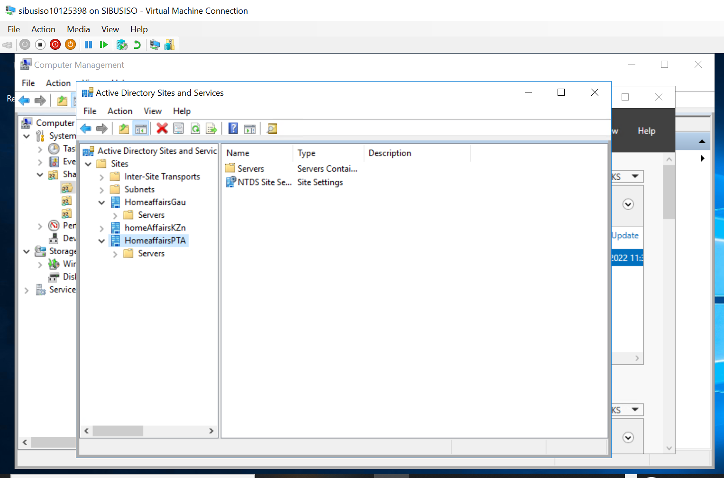

The server machine showing the entire structure of the network in the above picture.

### The domain server is adequately promoted and configured with server roles,

### features, and services. Domain server includes:

* Domain controller
* DNS
* DHCP
* 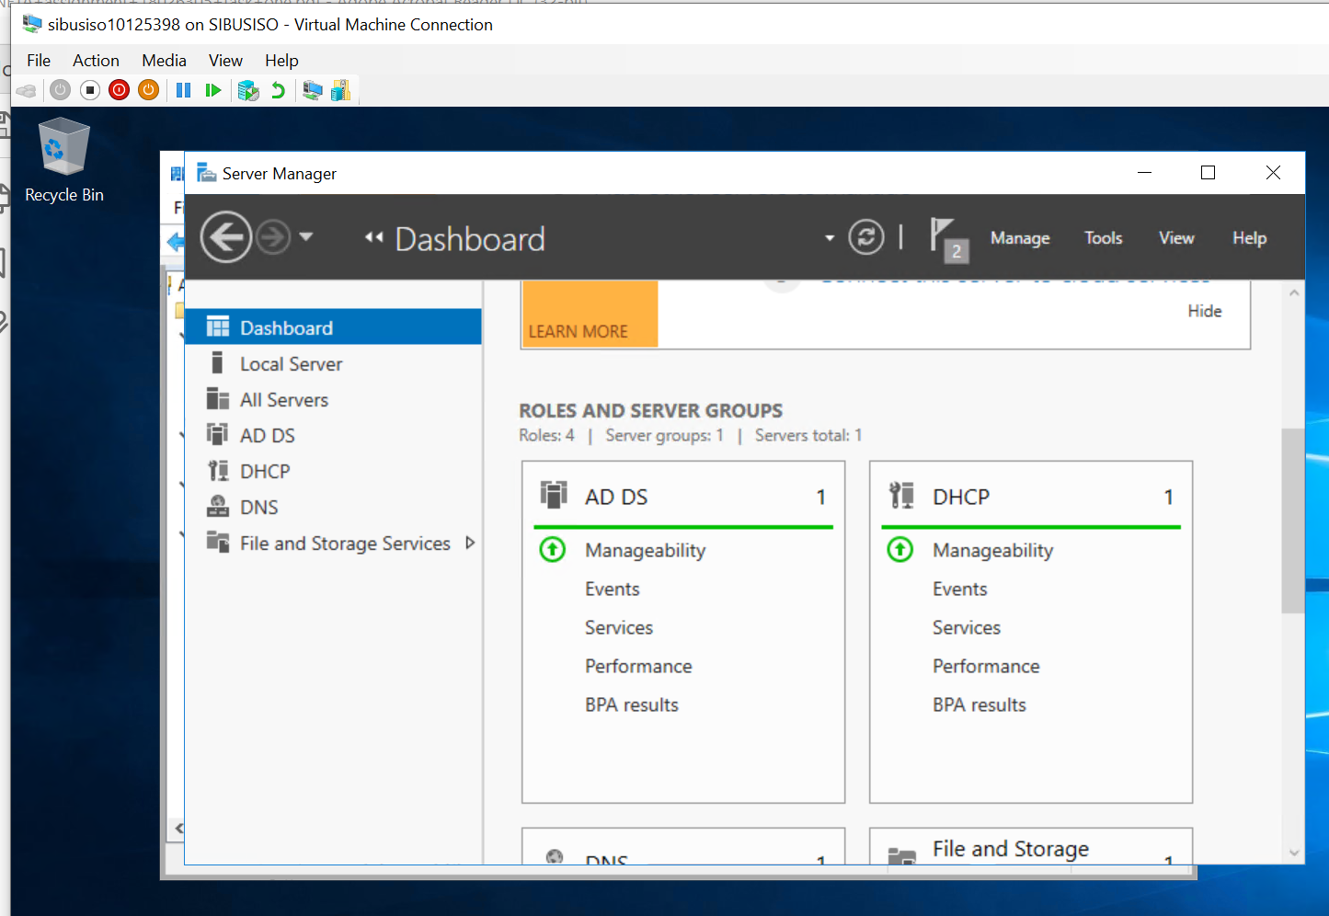

The above photo shows the DNS,Active directory and DHCP installed. The Domain Controller has been

installed for Home Affairs’ domain. DNS has also been installed for Home Affairs’ domain as well as

DHCP which has also been installed for Home Affairs’ domain.

### IP Addressing is adequately implemented

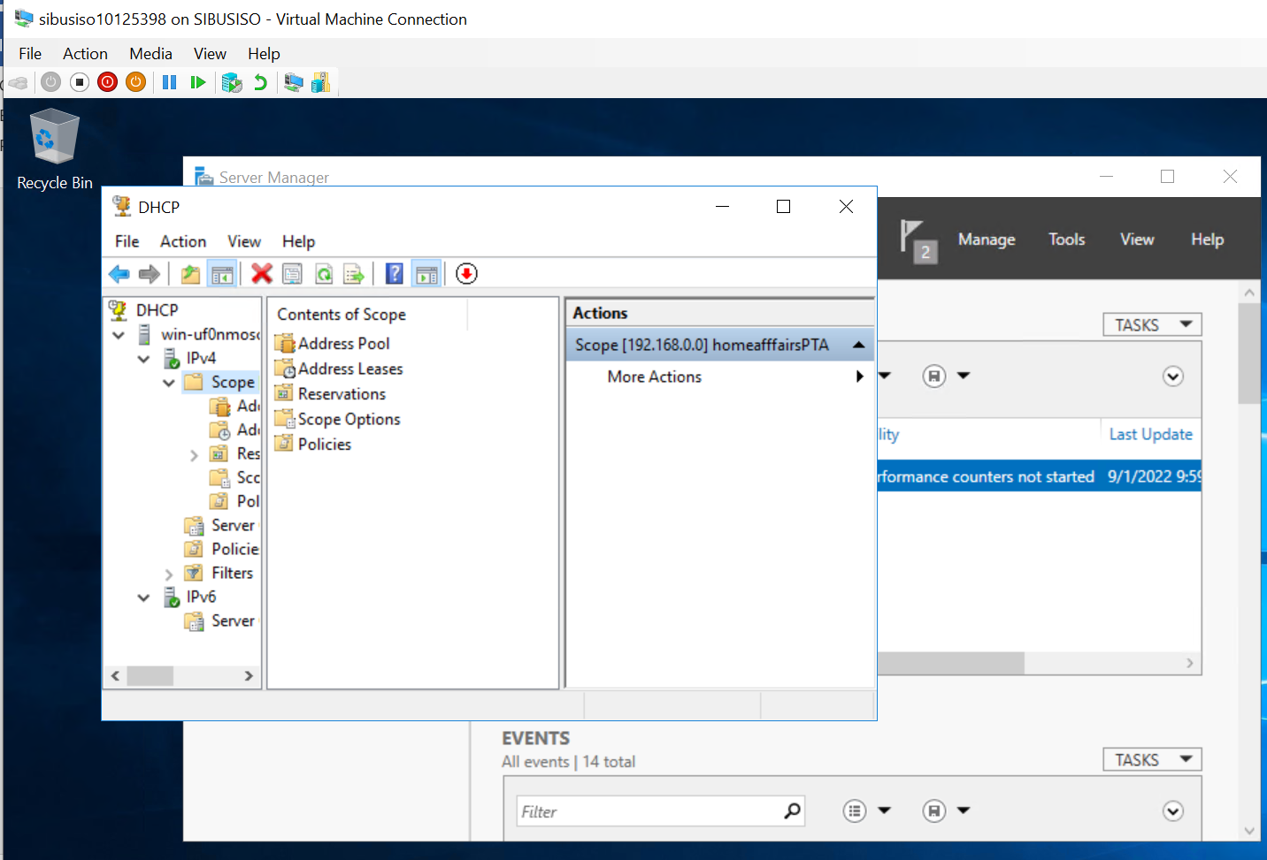

### Correct domain controller types are used per site. Includes:

• Head office – Domain Controller

• Branch office 1 – Read‐Only Domain Controller 1

Branch office 2 – Read‐Only Domain Controller 2

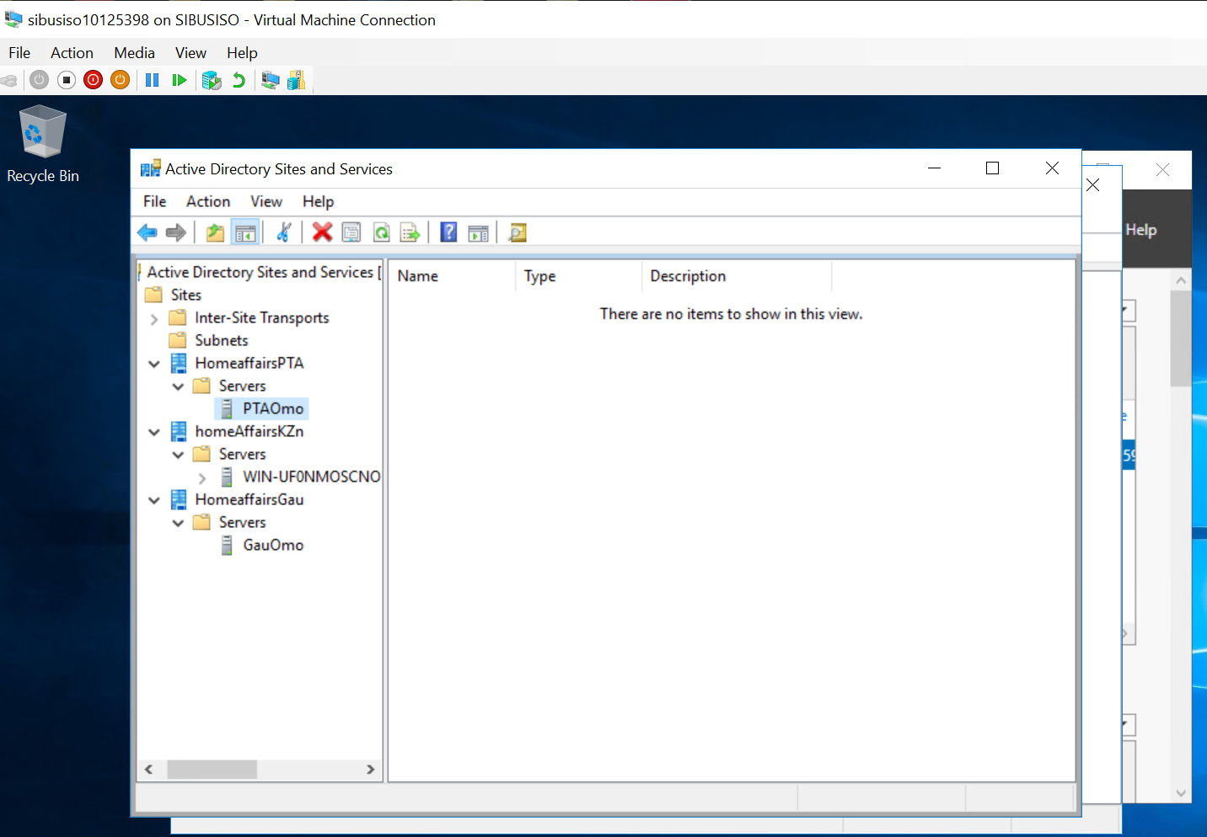

The above photo shows the Read only domain controller for the 2 branches.

### All three sites are adequately linked using site links.

Head Office is the main domain

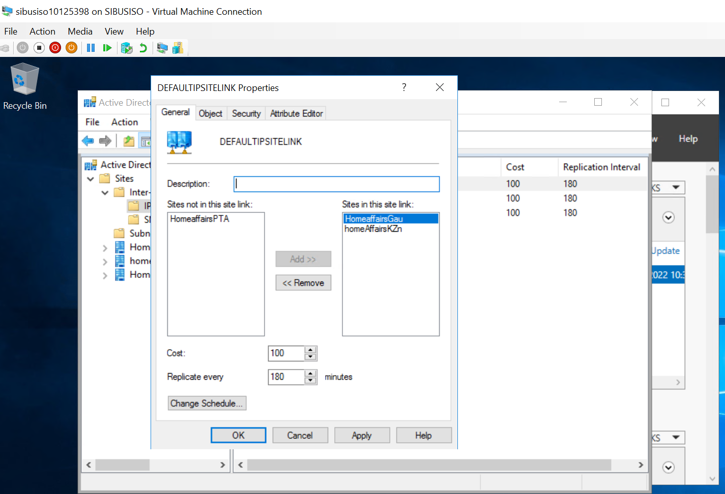

Branch office 2 is linked to the Head Office using an adequate link relationship

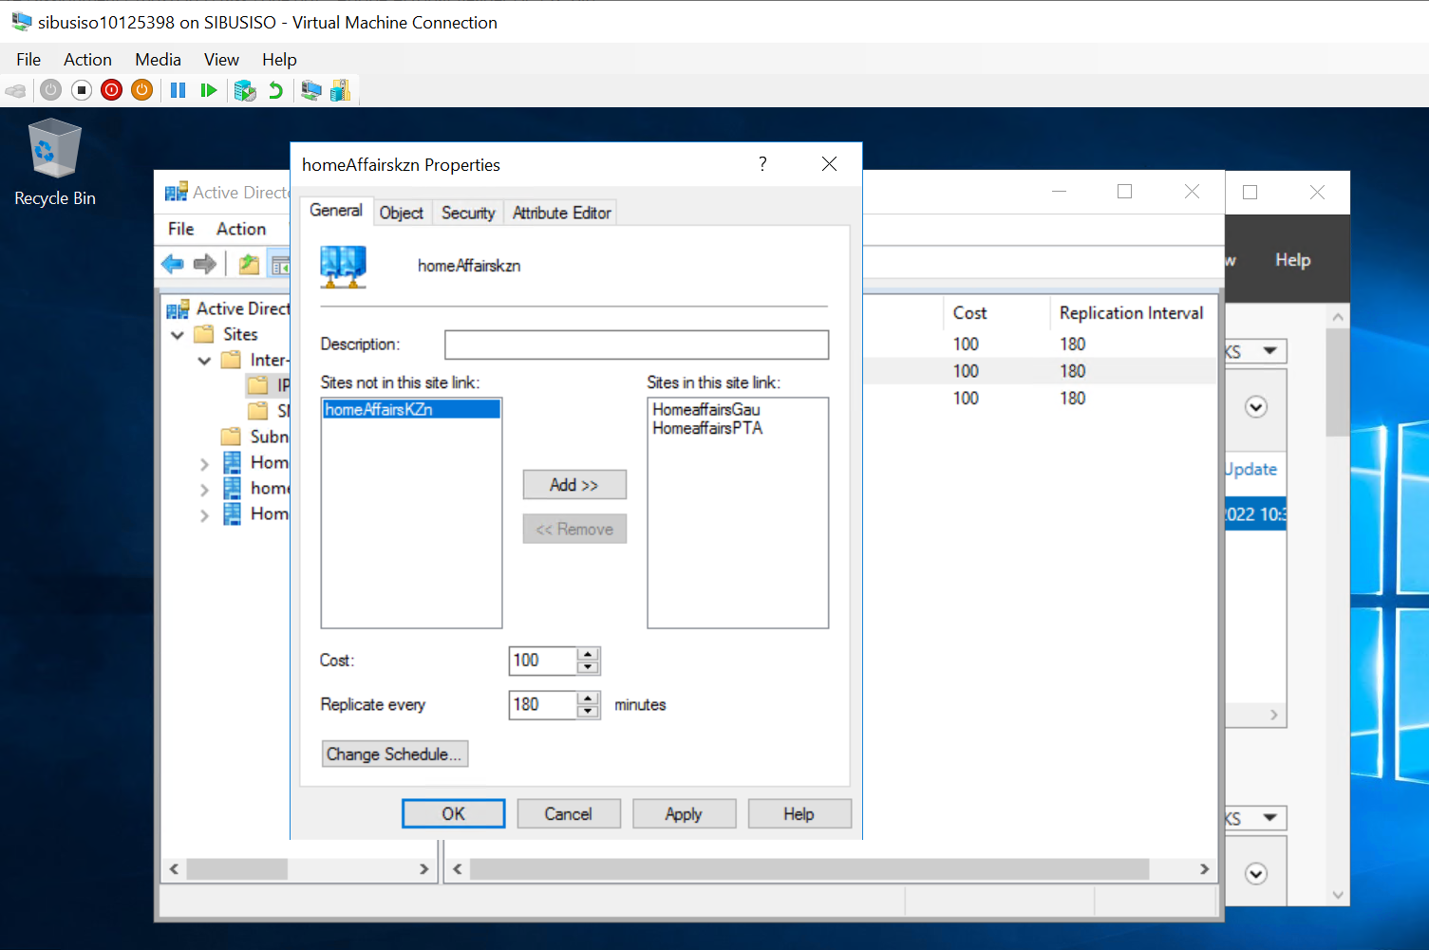

In the above image branch office 1 is linked to the Head Office using an

adequate link relationship.

### Active Directory user accounts are adequately created and configured

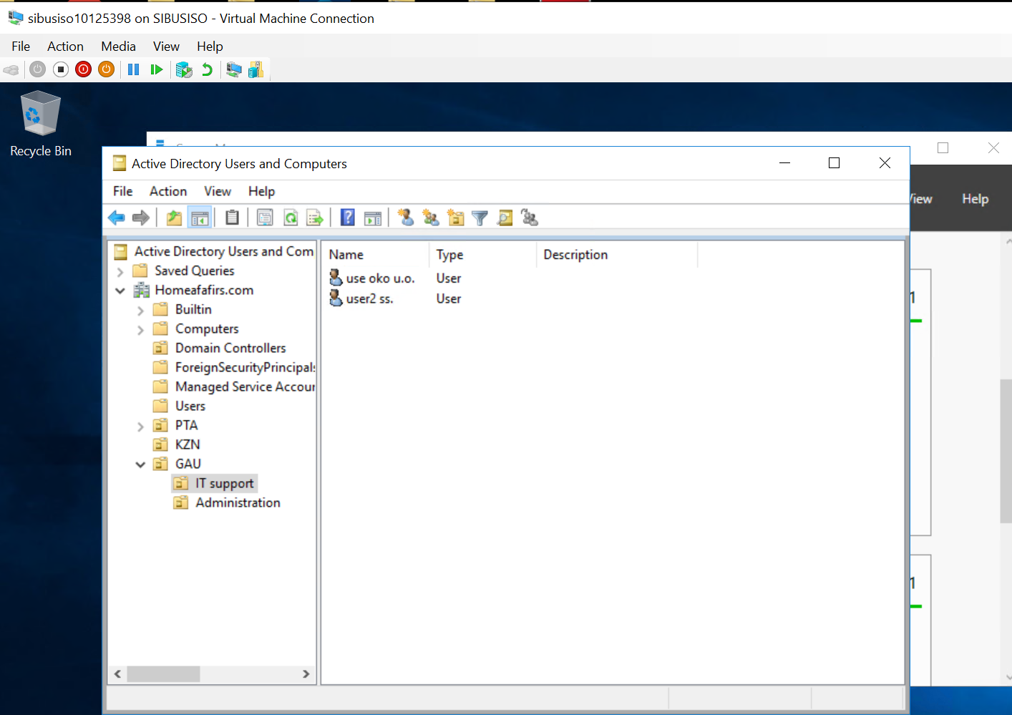

Active Directory user accounts are adequately created and configured

Includes adding members to group accounts.

Network shares are adequately created and configured.

